**Screenshots of the Practical Test**

**Compulsory [ Note : All Screenshots in the question order only ]**

1. IAM
   1. Set MFA for root account

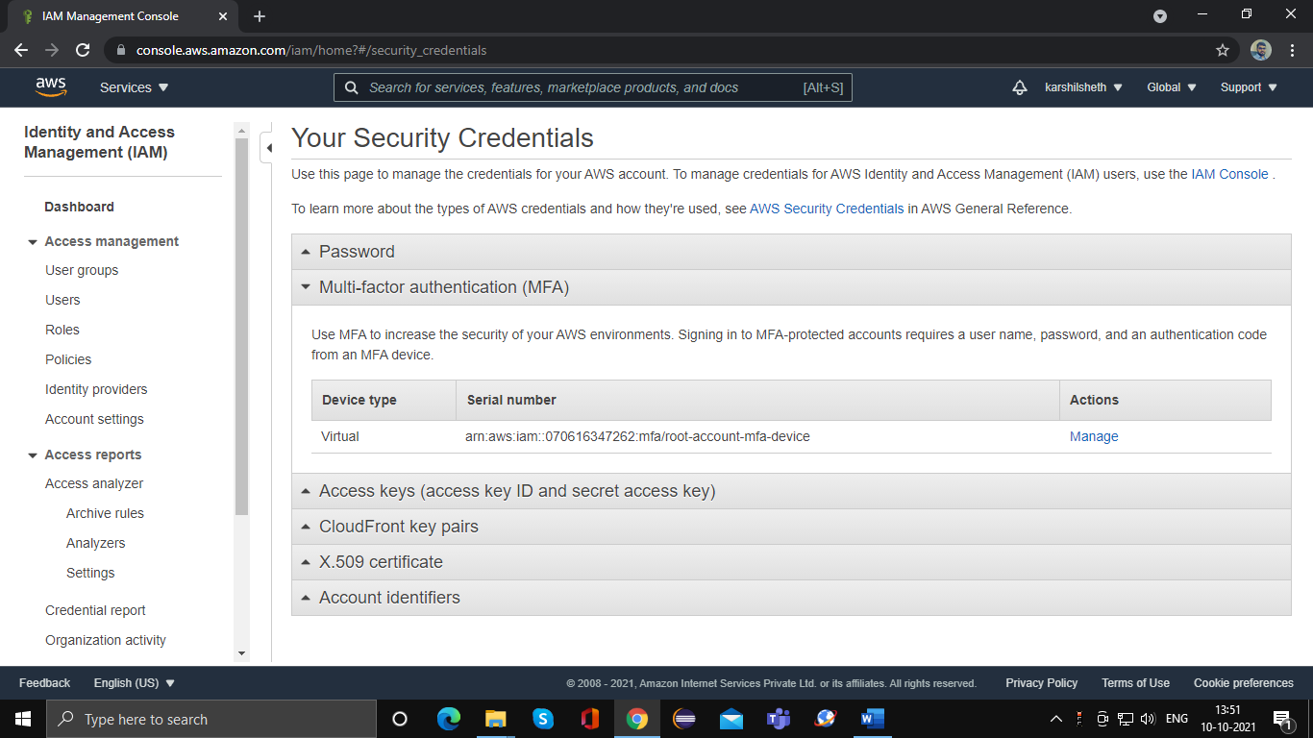

* 1. Create following IAM users , Admin, HRManager, ITAdmin, Employee

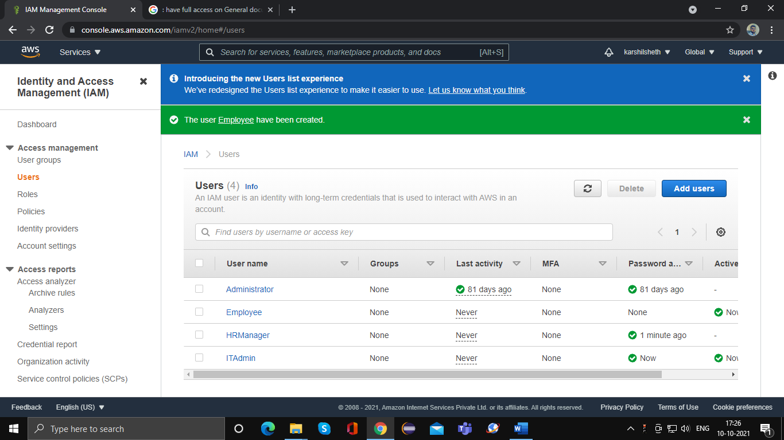

1. S3 Bucket
   1. Create one S3 bucket. Inside this bucket create three folders at same level
      1. Password
      2. Policies
      3. General documents

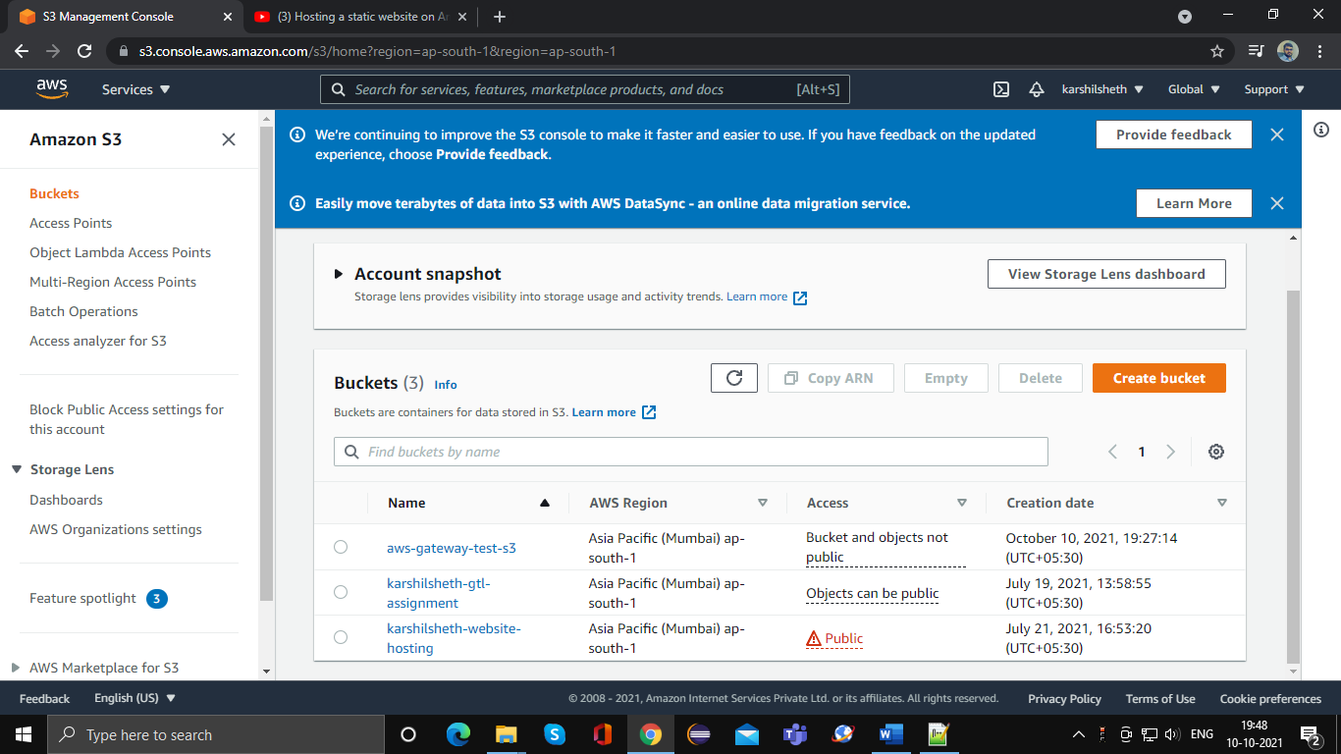

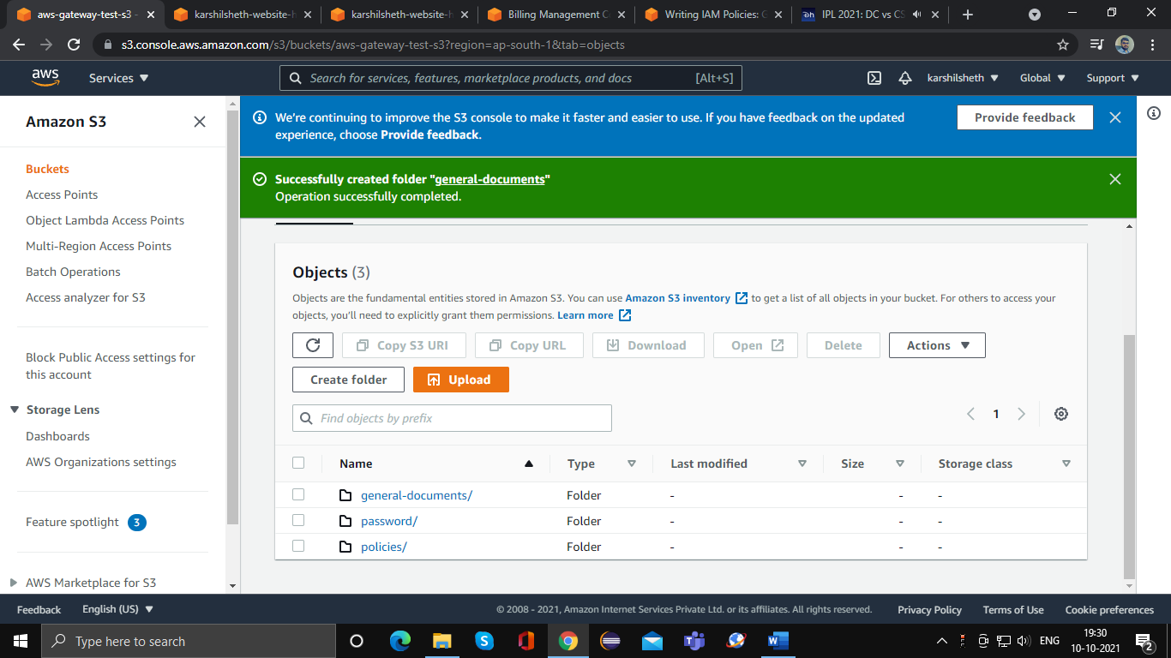

* 1. Create one bucket mywebsite and host static website in it

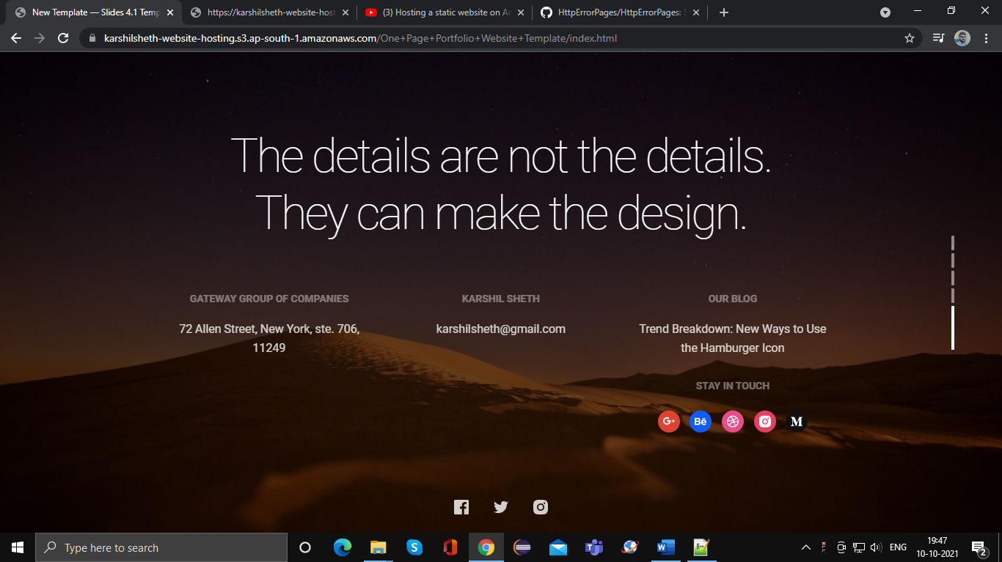

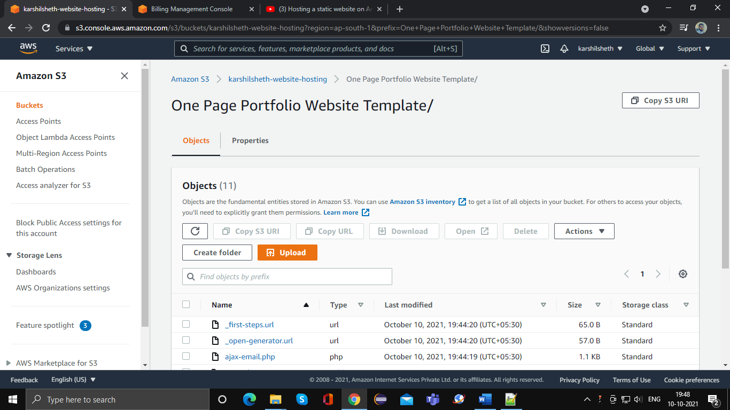

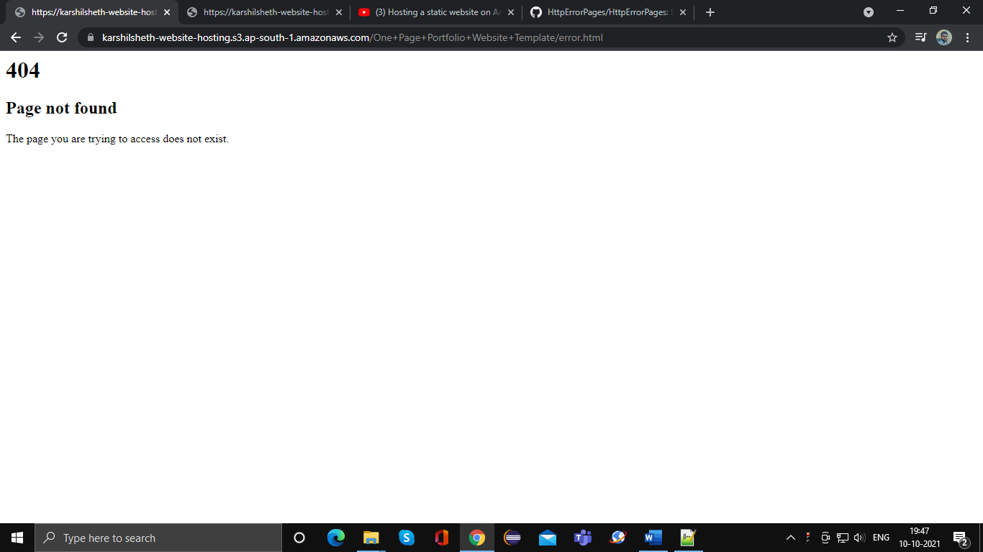

1. Create and associate S3 Policies for Admin, HRManager, ITAdmin, Employee IAM users
   1. Admin : can manage all operations with S3 bucket in all folders
   2. ITAdmin : can view all documents from General documents and Policies folder, but only have full access of Password folder to upload and download document
   3. HRManager: have full access on General documents and Policies folder, but should not able to see the content from Password folder
   4. Employee : Just have read permission on Policies and General Document folder. Should not able to see any document from any other folder, should not able to upload document

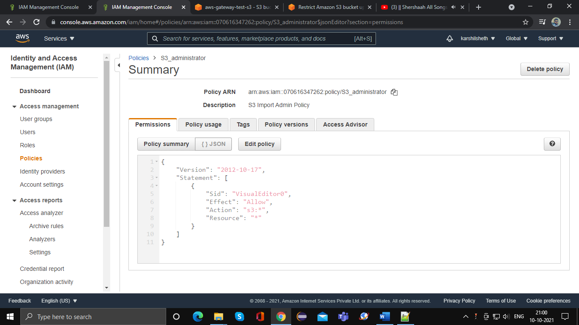

1. Create a Lambda function in your preferred (PHP,node,.net) language which send an Email using AWS email service

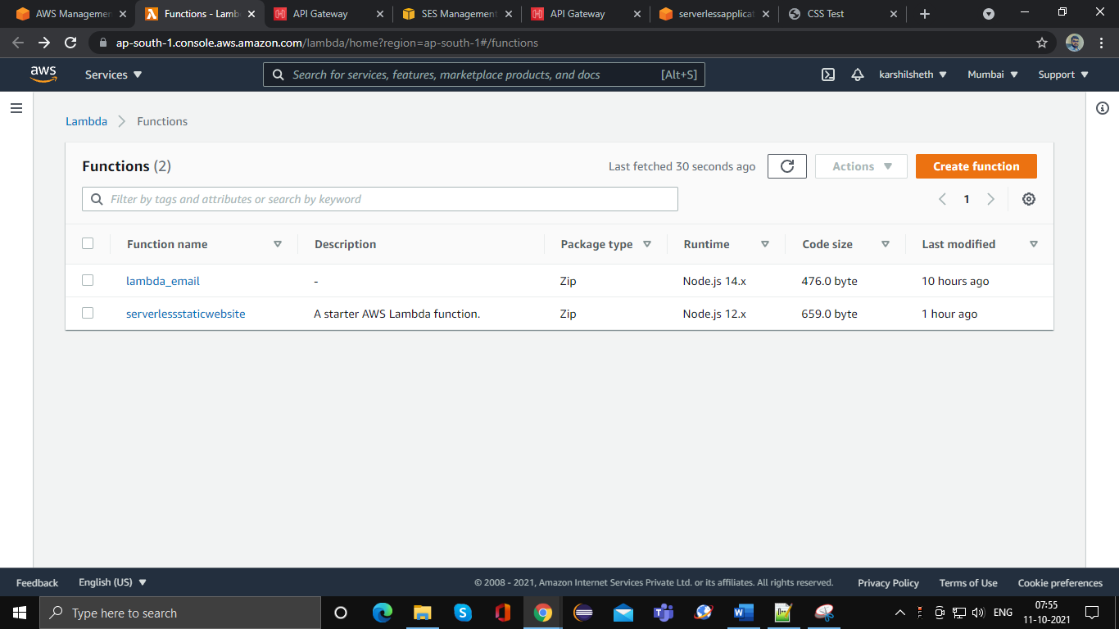

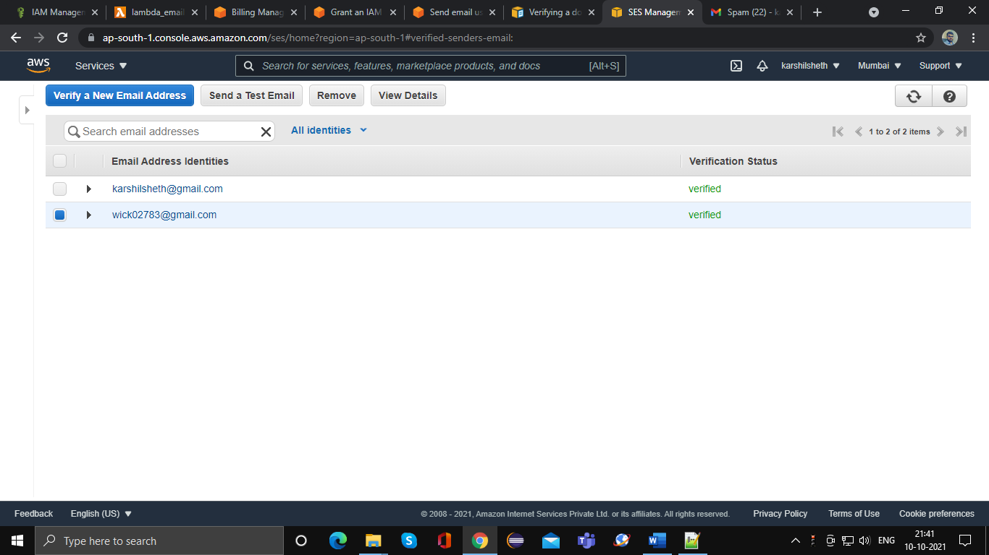

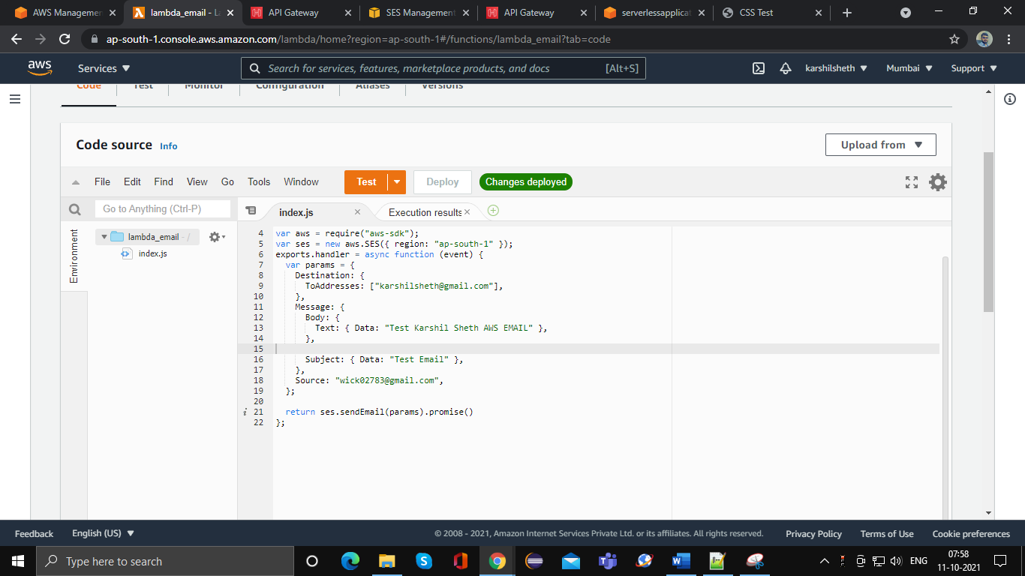

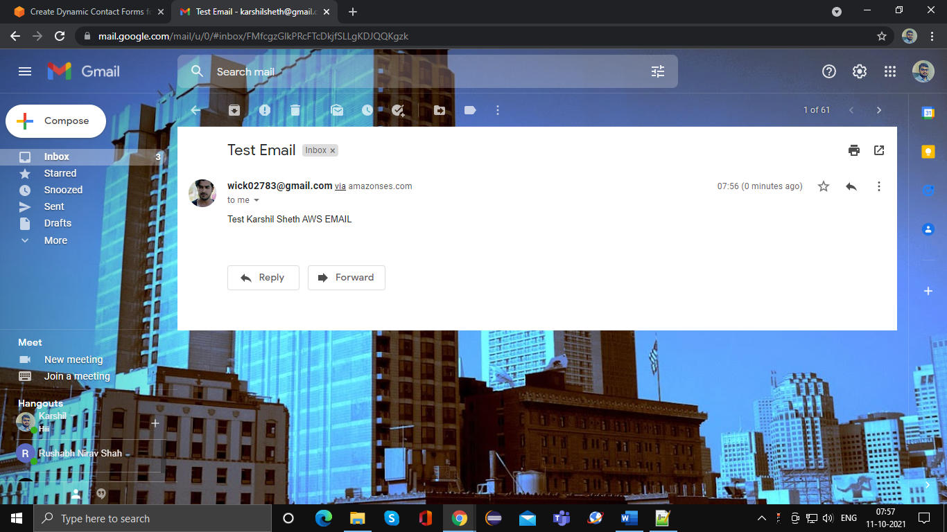

**Any Two**

1. Configure AWS CLI and execute following code
   1. Configure CLI with Admin user and upload document on S3 folder created above
   2. Validate security policy for followings
      1. Configure CLI with ITADMIN and
         1. List all the documents from all folders
         2. Upload all files from local folder to password folder
         3. try to upload document in Policies folder
      2. Configure CLI with HRManager and
         1. List all documents from Password folder

**Note**: For this practical you can take screenshot of each output and paste into a word document for verification

1. **Create a Serverless application**
   1. Upload static HTMLs with contact us page in S3 bucket
   2. Create an API gateway which call Lambda function. Lambda function sent email using AWS email service
   3. In contact us page call API gateway to send email notification

